Algorithm Worksheet

**Your Name: _________Rider Jensen_______ Course and Section: __CS 1400-001_**

**The purpose of this design worksheet is to help you organize your thoughts as you work out the solution to a particular programming problem. Filling out this worksheet is not busy work. Seasoned programmers know that it is much easier to write code once they have done the necessary design work. If you give your completed worksheet to someone else in the class, they should be able to write the program just from the information on this sheet.**

**What is the problem to be solved?** In the space below, try to write in your own words a brief statement of the problem that is to be solved in this project/lab.

Farmer john needs to calculate the area between four sizes of land on his farming grounds. The size of the area is a star that we need to calculate.

**What do I know?** In this space, write down any facts that you know about this problem. Leave out extraneous information – stick to the facts that are required to solve the problem.

We know that John has four plots of circular land with soy beans planted on it

We know that john wants the area of the land between those four plots found

**What can I visualize about the problem?** In the space below sketch any pictures, diagrams, or charts that might help you visualize the problem to be solved. Label values, make note of relationships, and look for patterns. Then write down any new facts that you have uncovered. If you found any mathematical relationships try to write down equations or formulas that express these relationships.

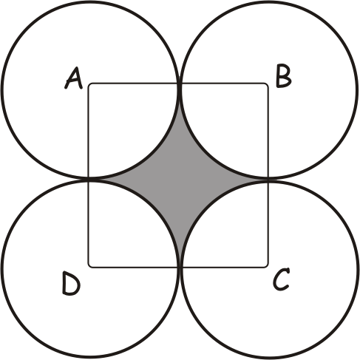

Circle circumference = 2*pi*r OR d*pi

Area of a square = L^2

**What do I need from the user?** In this space, write down any data that you need to collect from the user.

I need the diameter of one of the circles

**What will my program produce?** In this space write down what it is that your program will produce. Note any special formatting that may be required when you output this data.

My program should produce the area of the shaded region on the diagram

**Line-by-line description of what the program needs to do using Pseudocode:** Pseudocode is a list of English-like statements that precisely define the operations that your program will perform. In this space, write down line by line exactly what your program will do. Avoid using C# language. Include all of the details that are necessary if someone were to write the program using your pseudocode.

* The program should ask for the diameter of the circle from the user
* Convert this into a double
* Divide this in half to get R = Radius
* Find the area of the circle with A = pi*r^2
* Divide this number by 4 in order to get a quarter of the circle
* Find the area of one of the squares by taking the radius and doing A = r^2
* Subtract the quarter of the circle from the area of the square
* Multiple this number by 4 in order to find the total area of the shaded region
* Convert number into a string
* Display String in console

**Test Values:** In the space below, write down at least three different possible sets of input values that you can use to test this program. Using a calculator, spreadsheet, or by hand compute the answers that you believe your program should produce. **Use these values to test your final program.**

10 - 21.4

50 – 536.504592

100 – 2146.018368